CTM-I Use Case

Drop Copy

(Add)

Version 0.1

Use Case Name | Drop Copy Add
Actor | Market Ops, Operations, App Support
Pre-conditions /Assumptions | User has Browser and is aware of the http path to the application.  User has successfully logged into the CTM-I application.  User has the right role to see the menu options.
Post Conditions | None
Screenshot | 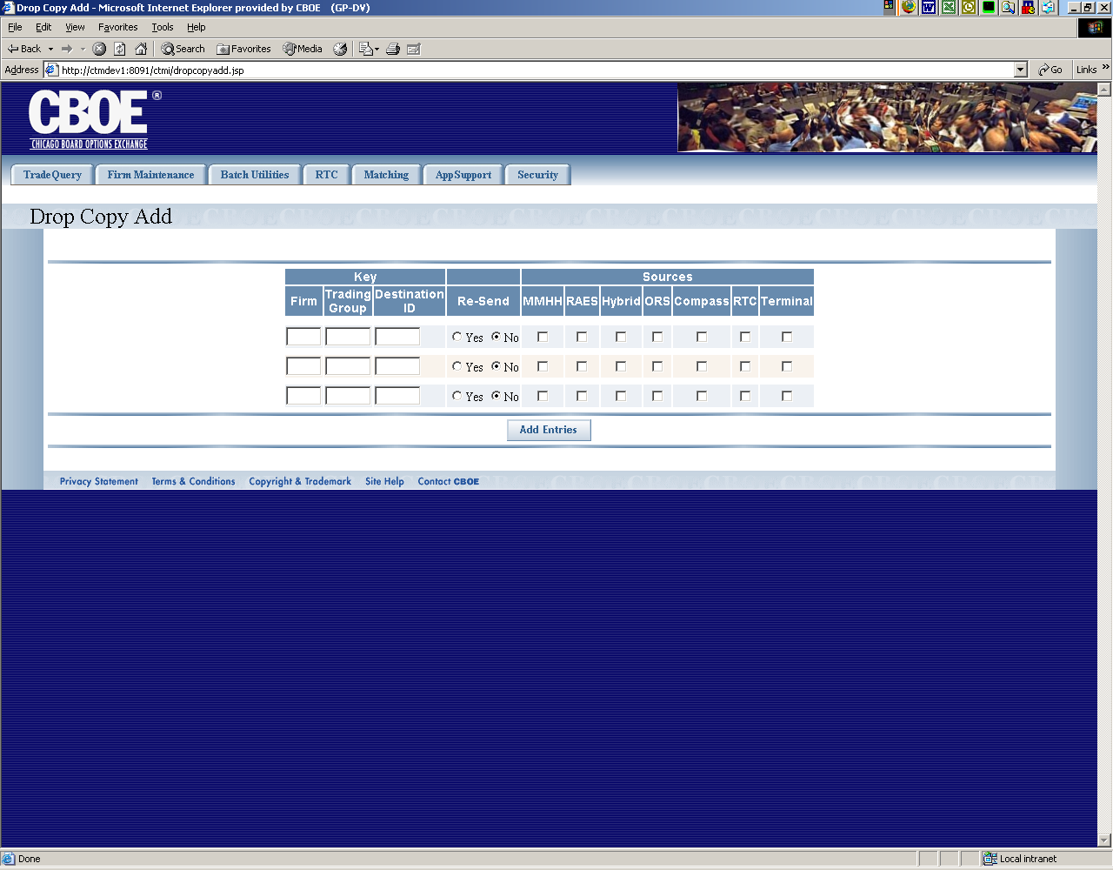
Flow of Events | - User selects “Drop Copy” from the menu.  - Click on the “Add Drop Copy entries” link.  - The Drop Copy Add screen appears displaying 3 row of data entry fields  - All rows of the table will be enterable, no paging will be done  - The data fields will enterable and are as follows  - Firm  - Trading Group  - Destination ID  - Re-Send (either Y or N)  - Market Maker Handheld (either checked or blank)  - RAES (either checked or blank)  - Hybrid (either checked or blank)  - ORS (either checked or blank)  - Compass (either checked or blank)  - RTC (either checked or blank)  - Terminal (either checked or blank)  - The user presses the “Add entries” button to add the entries  - Any records added will have the following defaults set in the record  - Transactions Add, Change, Delete and Dec will be set to “Y”  - The add to parm will be sent to CTM-R for processing  - The results of the CTM-R processing will be displayed to the user on the Drop Copy screen.  - After adding a drop copy entry the user is taken back to the display screen of Drop Copy.
Alternative Path | 1.1 List Alternative Flows Here.

